**Sensors and Signal Conditioning**

Austin Huang and Matthew Rodriguez

**Figures**

|  |  |  |  |
| --- | --- | --- | --- |
| Circuit Element | Circuit | Voltage with Light On | Voltage with Light Off |
| Photoresistor | Voltage Divider (5k Ohms) | 1.93 V | 0.43 V |
|  | Voltage Divider (10k Ohms) | 2.31 V | 0.53 V |
| Photodiode | Amplifier (100k Gain) | 3.02 mV | 2.56 |
|  | Buffer | 2.51 mV | 2.55 |
| Phototransistor | Amplifier (100k Gain) | 302.76 mV | 27.5 |
|  | Buffer with feed-back | 30.31 mV | 28.3 |

Figure 1: Table of circuit element output voltage results

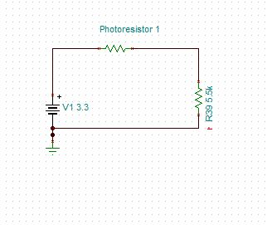

Figure 2: Tina-Ti schematic of Photoresistor circuit

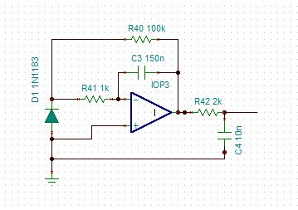

Figure 3: Tina-Ti schematic of Photodiode circuit

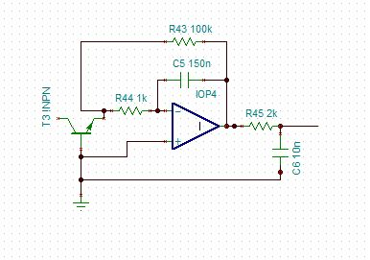

Figure 4: Tina-Ti schematic of Phototransistor circuit

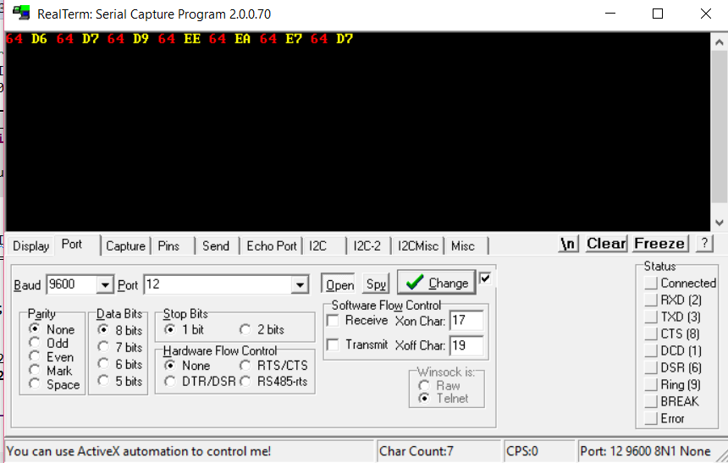

Figure 5: Photoresistor serial with light on



Figure 6: Photoresistor serial with light off



Figure 7: Photodiode serial with light on

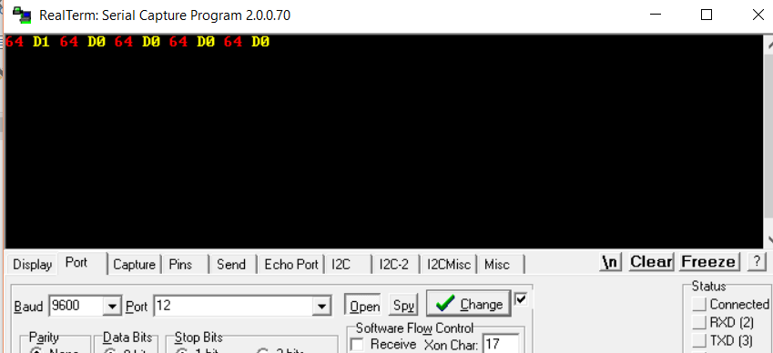

Figure 8: Photodiode serial with light off

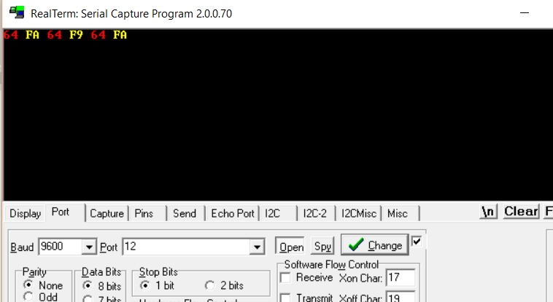

Figure 9: Phototransistor serial with light on



Figure 10: Phototransistor serial with light off

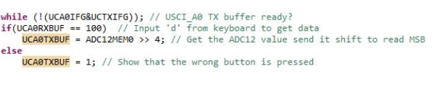

Figure 11: ADC code

**Synopsis of Circuit Elements**

The ADC value can be calculated by using the max value of the binary number that can be made with a specified number of bits. The binary number must be proportionate to the voltage value within the voltage range. Thus, it can be set up as a proportion as a certain number in binary out of the specified voltage value out of the max voltage value.

Photoresistor: Tested using voltage divider. The max voltage of the photoresistor needed to be kept below the 3.3V range. The correct resistor values were used to divide the voltage, so the output would stay below the range under any condition.

Photodiode: Photodiodes convert light (photons) into electrical current. Photodiodes can be used as sensors, since the amount of current emitted varies depending on how much light the photodiode receives. A circuit was built to test the photodiode and how it could be used to create a sensor for the lab.

Phototransistor: A light sensitive transistor can be used to create a sensor as well. Only the gate and drain were connected so that the transistor behaved as a diode.

**Results**

The 3 circuit elements (photoresistor, photodiode, and phototransistor) were tested to roughly estimate their minimum and maximum voltage outputs in a simple test circuit. The outputs of the circuit are checked so that they will not exceed a specified 3.3V, while their minimum values were also considered.

Photoresistor: Tested using voltage divider. The max voltage of the photoresistor needed to be kept below the 3.3V range. The correct resistor values were used to divide the voltage, so the output would stay below the range under any condition. The test circuit is shown in Figure 2. The results are shown in the table in Figure 1. Serial communication was also tested using RealTerm in Figure 5-6.

Photodiode: Photodiodes convert light (photons) into electrical current. Photodiodes can be used as sensors, since the amount of current emitted varies depending on how much light the photodiode receives. A circuit was built to test the photodiode and how it could be used to create a sensor for the lab. An amplifier was used to test the specified part of the circuit to increase the output of the photodiode circuit, since it generates incredibly small current. This allowed for the different readings to be seen in the varying lighting settings. The test circuit is shown in Figure 3. The results are shown in the table in Figure 1. Serial communication was also tested using RealTerm in Figure 7-8.

Phototransistor: A light sensitive transistor can be used to create a sensor as well. Only the gate and drain were connected so that the transistor behaved as a photodiode. The source was left unconnected. A similar circuit to the photodiode circuit was used to test the phototransistor. The input of the circuit was also amplified to create a larger output. The effect of the phototransistor is like that of the photodiode except the phototransistor is stronger. The test circuit is shown in Figure 4. The results are shown in the table in Figure 1. Serial communication was also tested using RealTerm in Figure 9-10.

**Code**

The code must be run in CCS and imported it into the MSP430. The MSP430 should be connected to the input of the sensor circuit. Open RealTerm to read the output values generated.

To show the ADC readings, the ADCXMEM0 value is printed on the TX Line as seen in Figure 10.

The process of setting up ADC10 and ADC12 are very similar with some minor differences.  The difference between 10 bit resolution and 12 bit resolution is in the initialization.  The ADC12 unlike the ADC10 uses “ADC12MEM0” as previously mentioned. ADC10 uses “ADC10MEM.” As with the difference in name, ADC12 is a 12 bit resolution while ADC is 10 bit resolution.